STUDENT NUMBER: ST10460935

STUDENT NAME: MANGENDA SILAS ADIABI

REPORT OF WEATHER ORGANISATION

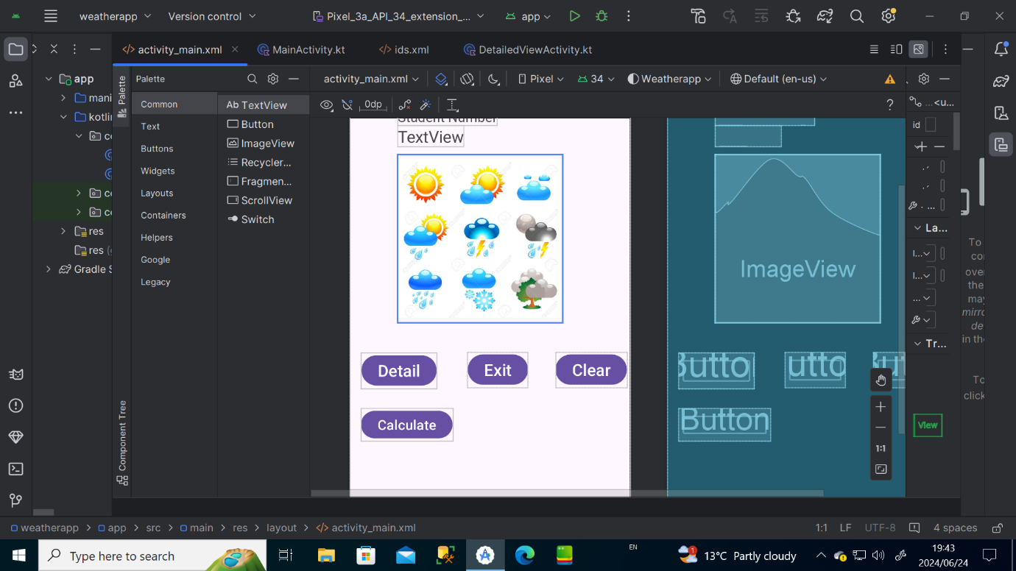

The Requirement is about to create an android app that I named weather organization App. The app has a button named Detail, where once the user clicked on, it will display my details, another button named Exit, to help user to exit the app, button Clear, to clean the information put in the app; a button to calculate temperature average.

The purpose of that app is to show to the user the local conditions weather for everyday from Monday to Sunday by displaying the daily temperature, weekly average temperature, and for each day, the app through the button, will show to the user, a message regarding the condition of that day if it is cold, hot, sunny….